Module 3

Robertson, Rashai

Bellevue University, CSD310

Assignment 3.2

4/06/2025

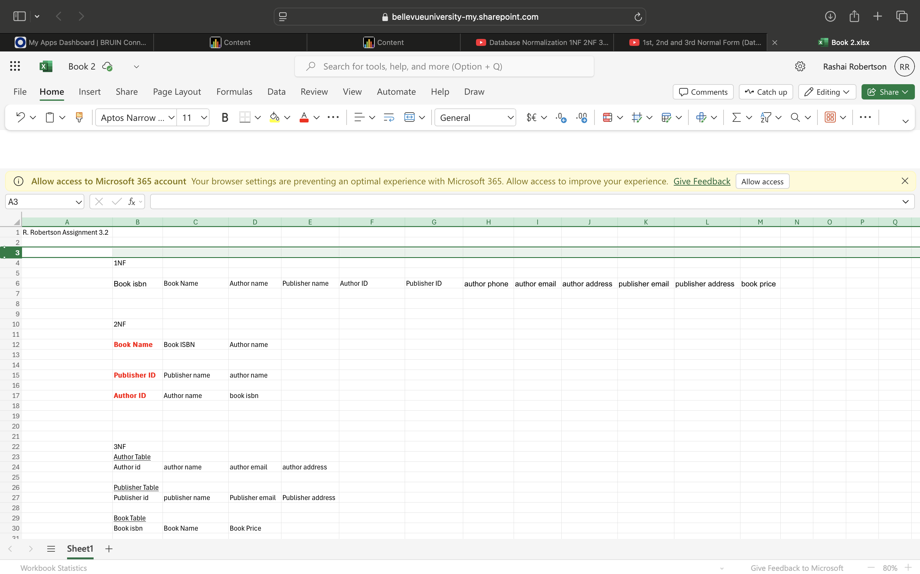

I couldn’t grasp the idea of how to make that set of data into normal forms. Everything I researched had extra data. I feel like the Assignment Data Fields were only headers. It confused me.